
Unit 4 Living with technology
Extended reading: Virtual Reality
- 内容分析：
【What】本板块的语篇是一段访谈脚本，对话双方分别为科技杂志的编辑和虚拟现实领域的专家。专家首先向读者介绍了虚拟现实的定义和原理；接着分别从教育、医学及日常生活等方面探讨了虚拟现实的实际运用领域和发展前景；在客观分析了阻碍虚拟现实技术发展的原因——时间、费用及技术局限后，专家表示自己对虚拟现实的未来还是抱有乐观态度的。
【Why】本板块的语篇通过对虚拟现实这一新兴科技的探讨和分析，旨在帮助学生认识虚拟现实技术的广泛运用，以及它将如何从方方面面改变人们的日常生活，让学生感受科技对生活产生的深远影响，以积极的态度对待虚拟现实技术的快速发展。
【How】本文的语篇类型为访谈脚本，通过科技杂志编辑和虚拟现实专家之间的对话展开全文，一方面，编辑的每个问题都起到开篇布局、承上启下的作用，构成了全文的主要框架，使读者明白语篇的主要目的以及结构特征；编辑轻松的语言风格也使读者能够共享其对虚拟现实技术的赞许和好奇。另一方面，专家对问题的回答则为读者提供了详实的信息，既有专业的说理，又有生动的例证，增强了文章的可信度和可读性。
- 教学目标：
By the end of this section, students will be able to:
1. summarize the related information about VR;
2. give examples of the applications of VR;
3. describe the future development of VR.
- 教学重难点：
Students will find it a little bit hard for them to:
1. describe how VR works;
2. imagine what the future life will be with VR development.
- 教学过程：
Step 1 Lead-in
Watch a short video: What is Virtual Reality?
Talk about with Ss: What words or phrases Ss have got in the video?
Examples: modern concept; VR headset; digitally; images; 3 dimensions; interact; real-world; trainings and simulations, etc.

Step 2 Free Talk
What do you think is the most important value of VR?
I think the most important value of VR is that it can create a virtual world which is indistinguishable from the real one. When used appropriately, this is definitely a game-changing approach for fields like education and entertainment. Although it is hard to tell whether creating a virtual world is a good thing, we can still look forward to the future development of VR.

Step 3 Reading
Listen to the interview and fill in the mind map.
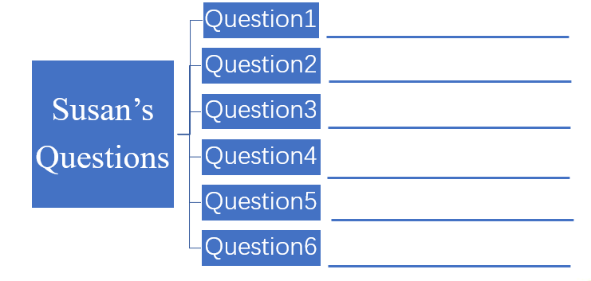

Key:
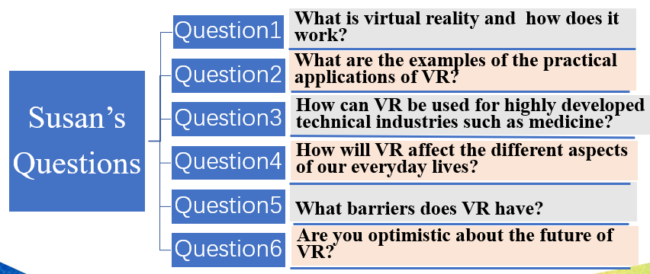

Step 4 Careful Reading
Fill in the table with the information from the interview transcript. (P54)
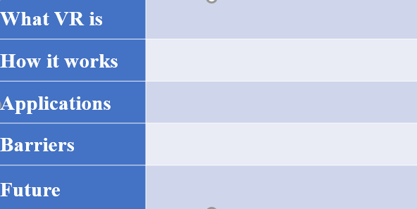
What VR is
How it works
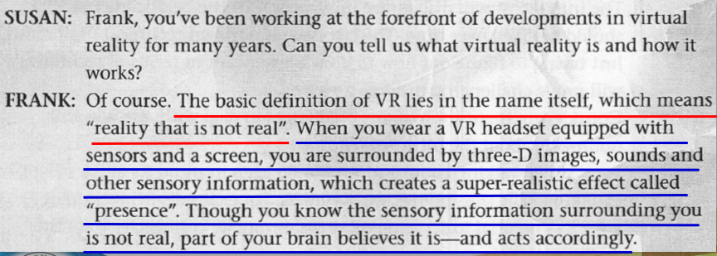

Applications:
Show Ss some gifs, and ask them in which field is each application.
Key: A. in education
B. in medicine
C. in entertainment
D. in shopping
E. in travelling

Barriers:
Time, cost and technical limitations.

Future:
There are endless possibilities.

Step 5 Discussion
What is the future like with the development of virtual reality?
Enjoy the video if time permits.

Step 6 Language points
- When you wear a VR headset equipped with sensors and a screen , you are surrounded by three-D images, sounds and other sensory information.(lines 5-7)
sensor n. 传感器，敏感元件，探测设备
sensory adj. 感觉的，感官的
Have a try: translation
1). The ultimate intention is to link up all the cars on the road via WiFi by setting up a WiFi-enabled sensor in a car.
最终的目标是把道路上所有汽车通过无线网络联系起来，在车内安装支持WiFi的传感器。
2). In spite of its importance to our emotional and sensory lives, smell is probably the most undervalued sense in many cultures.
尽管嗅觉对我们的情感和感官生活很重要，但在许多文化中，它可能是最被低估的感官。

- ... part of your brain believes it is—and acts accordingly. (lines 9)
accordingly adv. 相应地，照着；因此，所以
1). It is a difficult job and they should be paid accordingly. 相应地
2). The cost of materials rose sharply last year. Accordingly, we were forced to increase our prices. 因此

3. Imagine studying the solar system or the human body in a fully immersive environment. (lines 15-16)
immersive adj. 拟真的；沉浸式的；沉浸感的；
v. _____________ 使沉浸(于)，使深陷(于)；使浸没(于液体中)
adj. _____________ 浸入的，专注的
Answers: immerse; immersive
more phrases about “immerse”:
immerse oneself in/into sth./doing sth.
be immersed in/into sth./doing sth.
Have a try
1). Take notes and immerse __________ in the words of great thinkers.
2). One drawback is that children become fixated and ________ (immerse) in their screen time and become reluctant to exercise, __________ (result) in problems such as obesity.
3). You’d better trying living your customers’ lives and experiencing the __________ (immerse) realities of their media mix.
Answers: yourself; immersed; resulting; immersive
Can you think of more phrases on “专心做...”?
be immersed in / be indulged in
be buried in
be absorbed in
be involved in
be engaged in
be focused on
be concentrated on
bend one’s mind/efforts to sth.
keep one’s mind on sth.
devote ones attention to sth.

4. By delivering the content in a meaningful way, this new approach to learning manage to engage students’ interest and enhance learning efficiency. (lines 16-18)
engage v.允诺, 签约保证;雇用, 聘请; 参加, 从事;吸引,引起;适应,与……有密切关系;占用
engage的基本意思是“约定”,即凭借契约、誓言或诺言等约束人或事。用于约束别人,即表示“雇”“聘”; 用于约束自己,则表示“许诺”“保证”。这种允诺可信,有约束力,并将履行一段时间,如“订婚”等。引申可表示“占用,吸引,引起”或“使忙于,使从事”等。
Have a try
1). Jack and Anne are engaged (to each other). 订婚
2). I have engaged a room at this hotel. 预定
3). We engaged the services of a famous engineer. 雇佣
4). They never learned skills to engage the attention of the others. 吸引
5). The candidate’s apparent lack of engagement with younger voters. 与...有亲密关系
6). He engaged himself to pay back the money. 承诺,保证
7). I have never engaged in film shooting. 参与，从事
8). He is engaged in a game of tennis. 参与，忙于

5. Treatments of anxiety and drug addiction are other valuable and cost-effective application of VR. (lines 28-29)
addiction n. 沉溺，上瘾
be addicted to sth./doing sth.
cost-effective adj. 有成本效益的，划算的
or: cost- efficient
effective cost 实际成本

- The entertainment industry is one of the most enthusiastic advocates of VR. (lines 33-34)
advocate v. 提倡，拥护，支持，主张，鼓吹，为…辩护
n. 提倡者,拥护者；辩护律师,辩护人
1). He is a strong advocate of nuclear power.
2). Many experts advocate _________ (reward) your child for good behaviour.
3). He is a mountain climber, an inspirational speaker and an advocate for the disabled.

7. It won’t be long before virtual museums and interactive three-D exhibitions become common. (lines 36-37)
1). It won’t be…before…用不了多长时间就会…
2). It will be…before…得过多久才…
不用3个小时他就要到达这里。
It won’t be three hours before he arrives here.
他要3个小时才能到这里。
It will be three hours before he arrives here.

8. It really boils down to three things—time, cost and technical limitations. We will need time to develop and fine-tune... (lines 45-46)
boil down to 归结为，简化为
The issue really boils down to a clash between left and right.
fine-tune v.调试，微调
The government seeks to fine-tune other economic policies.

9. When talking about VR, we should keep in mind its quick rate of evolution. (lines 53-54)
keep in mind 牢记 (bear ... in mind)
evolution n.进化，发展，演变
vt & vi. ________ evolve
Many Victorians were shocked by the notion that Man had evolved from lower forms of life.
He has evolved a new theory after many years of research. 总结出

10. 5G technology, with its potential to serve up more stable mobile connectivity at faster speed, ... (lines 54-56)
serve up 提供，端上食物
e.g.:
The entertainers served up a lively show.
We are high up above the clouds now. The flight attendant will offer drinks and snacks soon. Just tell her what you want and she will serve it (up) to you
我们现在在高空云层中了。一会儿乘务员会提供饮料和零食。告诉她你想要什么，她就会给你端过来。

Step 7 Text review
1. When you wear a VR headset ______(equip) with sensors and a screen, you are surrounded by 3-D images, sounds and other ______ (sensor) information.
2. ... part of your brain believes it is—and acts ________ (according).
3. Imagine studying the solar system or the human body in a fully ___________ (immerse) environment.
4. By delivering the content in a meaningful way, this new approach _____ learning manage to engage students’ interest and enhance learning __________ (efficient).
5. Treatments of anxiety and drug __________ (addict) are other valuable and ___________ (成本低廉的) application of VR.
6. There must be some barriers _____ the development of VR.
7. Just trying to figure out how to do what we want ___ ____ ____ (就...而言，从...角度) technology will prove challenging in some areas.
8. Frank, you _________________ (work) at the forefront of developments in virtue reality for many years.

Answers: 1. equipped, sensory 2. accordingly 3. immersive 4. to, efficiency
5. addiction, cost-effective 6. to 7. in terms of 8. have been working

Step 8 Homework

