Unit 4 Living with technology
Integrated skills: Making a time capsule
- 内容分析：
本板块围绕单元话题，以“制作时间胶囊”创设情境，展开一系列具有综合性、关联性和实践性的听、说、读、写等语言技能训练。教学活动首先引导学生听一段介绍时间胶囊的广播节目；再让学生阅读一篇文章，厘清文中介绍的1939年世博会时间胶囊所包含的内容并理解爱因斯坦留给后代的信息；随后让学生围绕“设计给2050年的时间胶囊”这一话题进行讨论；最后过渡到“给2050年的人们写一封信”这一活动上。上述活动环环相扣，每个活动既有侧重点，又与其它活动又关联，构成“四步一体”的语言综合实践活动。
- 教学目标：
By the end of this section, students will be able to:
- understand the purpose and content of time capsules;
- interpret Einstein’s message to future generations in the 1939 time capsule;
- discuss detailed information about their time capsule for 2050;
- Write a letter to people in 2050.
- 教学重难点：
1. Knowing about and understand the detailed information about time capsule;
2. Writing an article.
- 教学过程：
Step 1 Lead-in
Ask students the question: What do the two pictures have in common?


Possible answer: Capsules
1. Have you heard of a time capsule?
2. What can a time capsule be used to do?
【设计意图：快速引入单元话题。】

Step 2 Listening
A1. Ask students to listen to the talk and decide whether the following statements are true (T) or false (F). Circle the incorrect information in the false statements and correct it in the blanks. (page 50)
1. In a “letter to the future”, the writer might describe his or her hopes and worries for future generations.
2. The time capsule associated with Steve Jobs was 15 feet long.
3. The 1983 time capsule was intended to be buried for 30 years.
4. The maker of the 2008 time capsule was worried that the Earth might suffer a terrible disaster.
Suggested answers: 1. F 2. F 3. F 4. T

A2. Listen to the talk again and complete the notes below.
Time capsules
Purpose of a time capsule
To provide a picture of (1) ____________________ at the time it was created
Things to be put in a time capsule
- Almost anything
- A “letter to the future”
Famous time capsules
- In 1983, Steve Jobs donated (2) __________ from his computer to be put in a time capsule, which was opened in (3) ________.
- A time capsule was launched to (4) _____________________________ in 2008. It contains a list of humanity’s most important achievements and personal messages, as well as copies of the (5) _______ of famous people like Stephen Hawking.

Suggested answers:
1. what life was like 2. the mouse 3. 2013
4. the International Space Station 5. DNA

Step 3 Reading
B1. Ask students to read the introduction to the time capsule and answer the following questions.(page51)
1. What were the purpose and contents of the 1939 time capsule?
2. What was Einstein’s message to future generations about?
3. Why do you think he wrote the message with mixed feelings?
Suggested answers:
1. To show the people living in the year 6939 what life was like in America at the time the capsule was created.
The time capsule contained a wide variety of objects, like a toothbrush, a fountain pen, microfilm rolls and a message written by Albert Einstein.
2. It was about the technological progress man had made and Einstein’s predictions that future generations would read his message with feelings of pride and justified superiority.
3. He felt a mixture of pride and worry probably because on the one hand, America had achieved many great things unimaginable to people in the past, but on the other hand, serious social problems were developing in his time.

Useful words and expressions
- world fair 世界博览会
- a variety of 各种各样的
- be rich in 在...很丰富
- inventive minds 有创造力的头脑
- relieve people from... 把人们从...中解放出来
- be colored by 受到...的影响
- justified superiority 合理的优越感

Step 4 Discussion
C. In pairs, discuss ideas for your time capsule that will be opened in 2050 with the help of the questions in Part C on Page 52 to make up a dialogue.

1. What would you like to tell people in the future?
2. Imagine that you need to put a technological product in the time capsule, what would you choose? Why?
3. What hopes and wishes do you have for the future?

Step 5 Writing
D. Write a letter to people in 2050. Use your ideas from part C and the information in parts A and B to help you.
Learning about the structure
When writing a letter to people in the future, follow the structure below:
Describe what life is like in your time.
Focus on one technological product and explain how it is changing people’s lives.
Conclude your letter with your hopes and wishes for the future.
Learning about writing techniques
It is a good idea to give specific statements rather than general ones, which makes it easier to get your ideas across. For example:
We are living in a great age. (general)
We are living in an age when the Internet makes it possible for us to stay connected wherever we are. (specific)
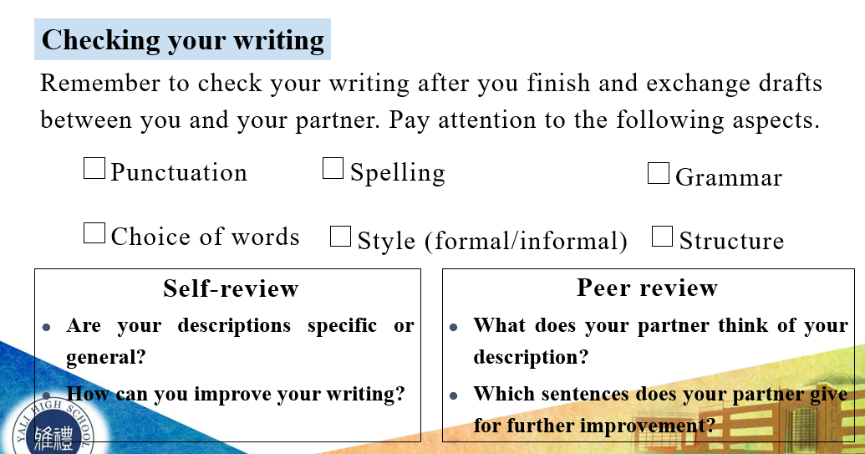
Sample
A letter to people in 2050
Dear friends from the future,
Greetings from the past! We are currently living in an exciting time that is full of amazing discoveries, especially in science and technology. Some especially important technologies that we use today are the Internet and artificial intelligence, without which the smart phone would not be possible. I have placed a typical smart phone in the time capsule for you to see.
The smart phone is a relatively new invention, but these days people could hardly live without it. It is extremely important for most people because it makes our lives more interesting and convenient. We use the smart phone for many things besides messaging and calling, such as surfing the Internet, shopping online, and using virtual directions. I also have a lot of photos on it about my daily life, such as the food I eat, the clothes I wear and the sport I play. I wonder if you still use smart phones in the future or if you instead use some type of smart implant technology!
In the future, I hope that you will have a more balanced life with technology. I sometimes think that we rely too much on it. While I do not want to lose the advantages smart phones and other technologies bring, it would be nice for people to spend a bit less time using them. That is all for now! I hope you enjoyed seeing what life is like in my time!
Yours, Jessie Chen

Step 6 Homework
Polish up your writing and make a presentation to the class.
【设计意图：明确语篇特点，锻炼写作技能。】

